Limits; What’s Better?

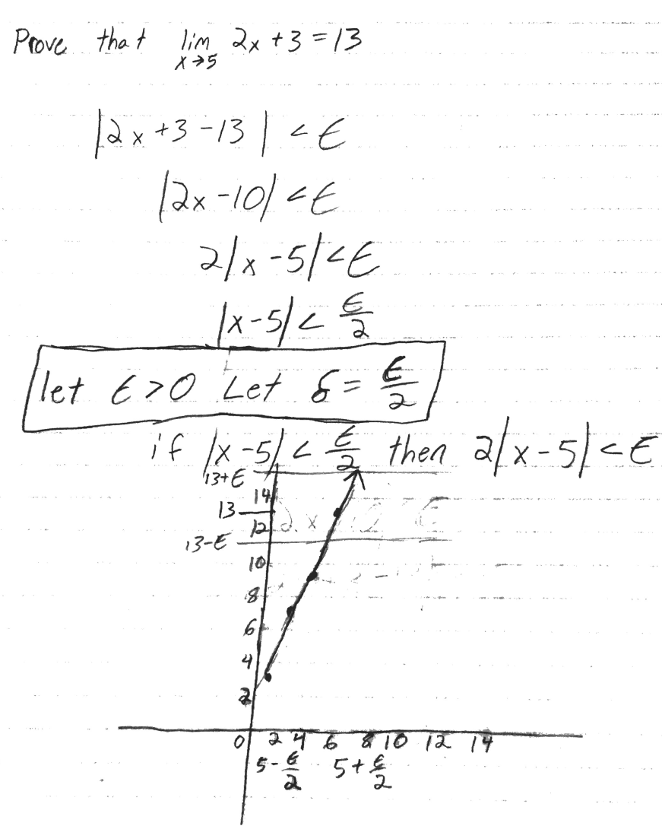

Explain why this definition of a limit is “better” than what was used by Newton Leibniz, et al. How does this definition avoid the problems of Newton, Leibniz, et al?

The above example uses the epsilon-delta definition of a limit, where 2x + 3 is a function f(x) and x is a value that can get infinitely close to 5, but not equal to 5. This means we can make epsilon be whatever we want and get a delta value that will be in the range for the given limit. This definition is more precise than what Newton or Leibniz came up with because it illustrates that a value ‘x’ can get infinitely close to another value without ever reaching that value and it also illustrates that any given epsilon will be within the range of the limit. Newton explained limits as “Those ultimate ratios ... are not actually ratios of ultimate quantities, but limits ... which they can approach so closely that their difference is less than any given quantity...” (Definition of limit). The epsilon-delta definition of a limit is better than what Newton and Leibniz used, because it creates a way for us to see what values can be in the range of the limit.